University of Gujrat
Department of Software Engineering
Submitted by:
Muhammad Aliyan
25021598-245
Section:
AB
Submitted to:
Miss Reema Chaudhary
Date Submitted:
12/18/2025
Contents
Strings Practice 3
Code 3
Output 4

Q1: Library Management (Mini System)

Code

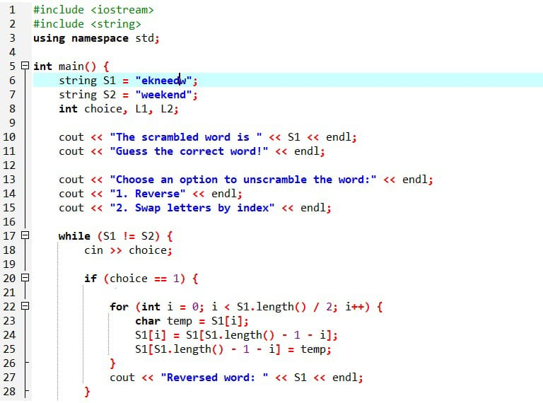

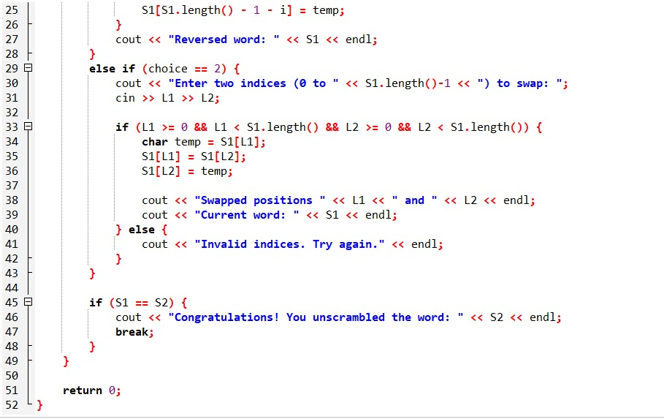

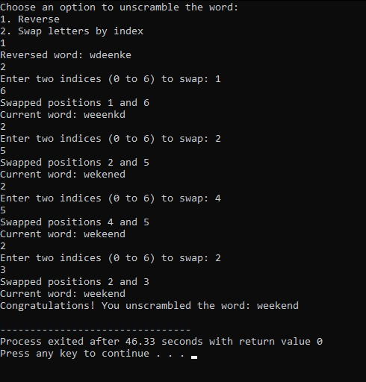
Output

